

## Wednesday 13th October, 2021

www.welshpharmacyawards.info

028 9099 9441

The Vale Resort, Glamorgan

### Application

# Independent Community Pharmacist of the Year

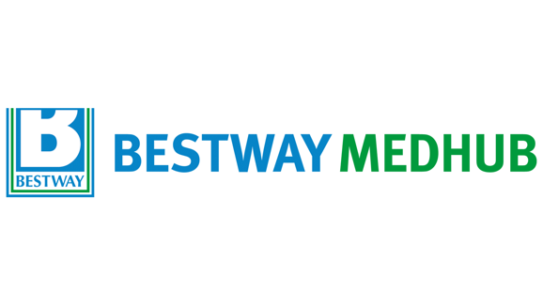

## Sponsored by

### Deadline for Entry:

The closing deadline for application is **7th July** and entries must be accompanied by a digital photograph, **at least 500KB** for printing quality.

Send completed application form to [chris.flannagan@nimedical.info](mailto:chris.flannagan@nimedical.info).

For any additional information call 028 9099 441.

### How to Enter:



The Vale Resort, Glamorgan

www.welshpharmacyawards.info

028 9099 9441

## Wednesday 13th October, 2021

## Sponsored by

# Independent Community Pharmacist of the Year

### Name:

### Pharmacy Address:

### Telephone:

### Email:

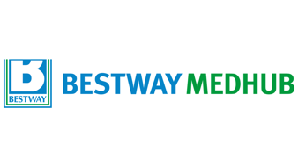

### 1. What are the main challenges you face on a daily basis and how do you overcome these?

### ?

### Enter text here:

### 2. What processes have you put in place within your pharmacy to deliver a personalised, confidential, patient-centred service?

### Enter text here:

### 3. How have you integrated with the surrounding community i.e. via community projects, special clinics etc.?

### Enter text here:



## Wednesday 13th October, 2021

028 9099 9441

www.welshpharmacyawards.info

The Vale Resort, Glamorgan

### Enter text here:

### Enter text here:

### 5. Given no restraints, how would you develop the role of the community pharmacist over the next 10 years?

### 4. Give evidence of how you measure an improvement in patient outcomes.

Please email entry form to: chris.flannagan@nimedical.info.

Or if you require any further information please contact Chris Flannagan:

Tel: 02890 999 441.

Entries MUST be accompanied by a digital photograph, at least 500KB for printing and multimedia quality.