

## Wednesday 13th October, 2021

www.welshpharmacyawards.info

028 9099 9441

The Vale Resort, Glamorgan

# Independent Community Pharmacy Practice of the Year

## Sponsored by

### Application

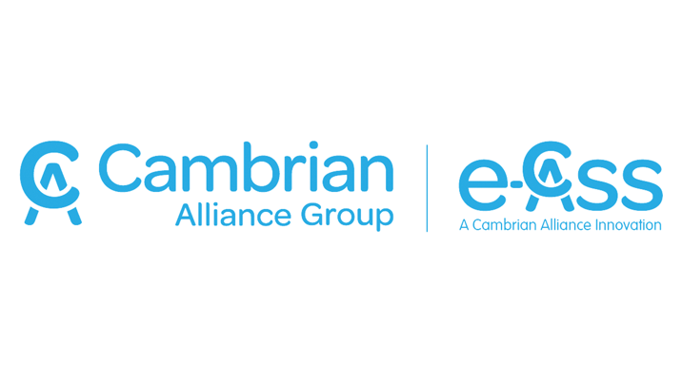

Send completed application form to [chris.flannagan@nimedical.info](mailto:chris.flannagan@nimedical.info).

For any additional information call 028 9099 441.

### How to Enter:

The closing deadline for application is **7th July** and entries must be accompanied by a digital photograph, **at least 500KB** for printing quality.

### Deadline for Entry:



The Vale Resort, Glamorgan

www.welshpharmacyawards.info

028 9099 9441

## Wednesday 13th October, 2021

## Sponsored by

# Independent Community Pharmacy Practice of the Year

### Name:

### Pharmacy Address:

### Telephone:

### Email:

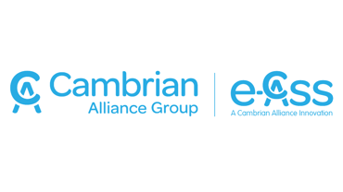

### 2. What initiatives or developments have taken place within the pharmacy, by you or members of staff, over the last 12 months?

### 3. Have you worked with any GP surgeries, community groups etc. in the last 12 months? (please give details about the work)

### Enter text here:

### 1. Give a brief description of your pharmacy and what you offer the community.

### Enter text here:

### Enter text here:



## Wednesday 13th October, 2021

028 9099 9441

www.welshpharmacyawards.info

The Vale Resort, Glamorgan

Please email entry form to: chris.flannagan@nimedical.info.

Or if you require any further information please contact Chris Flannagan:

Tel: 02890 999 441.

Entries MUST be accompanied by a digital photograph, at least 500KB for printing and multimedia quality.

### Enter text here:

### Enter text here:

### 5. Have you undertaken any recent health promotion initiatives or events designed to tackle problem areas within your community?

### 4. How have you created a positive regarding the enhancement of patient care?