

## Wednesday 13th October, 2021

www.welshpharmacyawards.info

028 9099 9441

The Vale Resort, Glamorgan

# Hospital Pharmacy Team of the Year

## Sponsored by

### Application

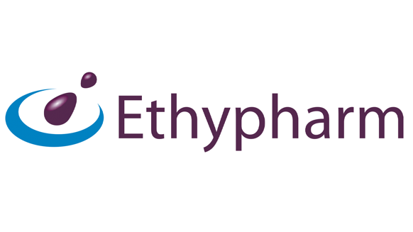

### Deadline for Entry:

Send completed application form to [chris.flannagan@nimedical.info](mailto:chris.flannagan@nimedical.info).

For any additional information call 028 9099 441.

### How to Enter:

The closing deadline for application is **7th July** and entries must be accompanied by a digital photograph, **at least 500KB** for printing quality.



The Vale Resort, Glamorgan

www.welshpharmacyawards.info

028 9099 9441

## Wednesday 13th October, 2021

## Sponsored by

# Hospital Pharmacy Team of the Year

### Name:

### Pharmacy Address:

### Telephone:

### Email:

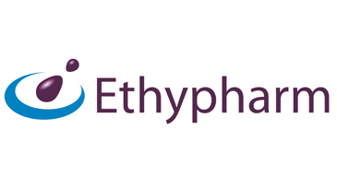

### Enter text here:

### 1. Describe your team’s background working within the hospital pharmacy sector.

### 2. What qualities have your team demonstrated which have helped improve and enhance the provision of pharmaceutical care within the hospital setting?

### Enter text here:

### 3. Please give two examples of initiatives your team have undertaken which have led to a positive impact for your patients.

### Enter text here:



## Wednesday 13th October, 2021

028 9099 9441

www.welshpharmacyawards.info

The Vale Resort, Glamorgan

### Enter text here:

### Enter text here:

### 5. If possible, give an example of how your team has reduced costs while increasing the level of patient care within your hospital.

Please email entry form to: chris.flannagan@nimedical.info.

Or if you require any further information please contact Chris Flannagan:

Tel: 02890 999 441.

Entries MUST be accompanied by a digital photograph, at least 500KB for printing and multimedia quality.

### 4. How has your team interacted and worked in a multidisciplinary way with pharmacy colleagues from other hospitals and the community setting?