

## Wednesday 13th October, 2021

www.welshpharmacyawards.info

028 9099 9441

The Vale Resort, Glamorgan

### Application

# Patient Safety Development in Secondary Care

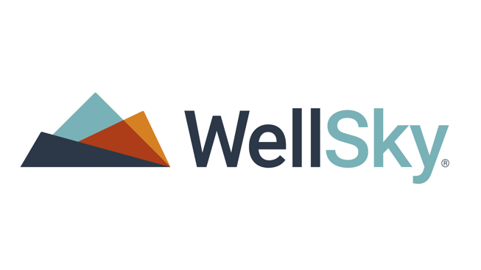

## Sponsored by

Send completed application form to [chris.flannagan@nimedical.info](mailto:chris.flannagan@nimedical.info).

For any additional information call 028 9099 441.

### How to Enter:

### Deadline for Entry:

The closing deadline for application is **7th July** and entries must be accompanied by a digital photograph, **at least 500KB** for printing quality.



The Vale Resort, Glamorgan

www.welshpharmacyawards.info

028 9099 9441

## Wednesday 13th October, 2021

## Sponsored by

# Patient Safety Development in Secondary Care

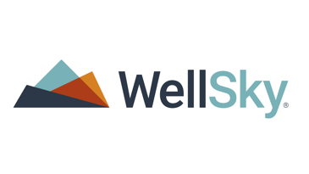

### Name:

### Pharmacy Address:

### Telephone:

### Email:

### Enter text here:

### Enter text here:

### 2. What objectives did you set out and why?

### 3. Describe the development of your goals and the eventual outcome?

### Enter text here:

### 1. When did you decide to enhance patient safety measures and why?



## Wednesday 13th October, 2021

028 9099 9441

www.welshpharmacyawards.info

The Vale Resort, Glamorgan

### Enter text here:

### Enter text here:

Please email entry form to: chris.flannagan@nimedical.info.

Or if you require any further information please contact Chris Flannagan:

Tel: 02890 999 441.

Entries MUST be accompanied by a digital photograph, at least 500KB for printing and multimedia quality.

### 5. What have been the main benefits for patients and colleagues in the hospital?

### 4. Have you encountered any challenges / difficulties throughout the project?