

## Wednesday 13th October, 2021

www.welshpharmacyawards.info

028 9099 9441

The Vale Resort, Glamorgan

### Application

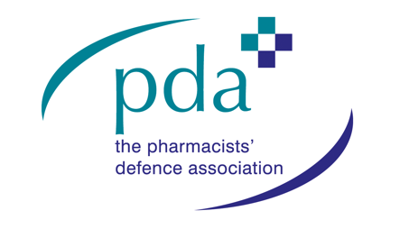

# Pharmacy Student Leadership

## Sponsored by

The closing deadline for application is **7th July** and entries must be accompanied by a digital photograph, **at least 500KB** for printing quality.

Send completed application form to [chris.flannagan@nimedical.info](mailto:chris.flannagan@nimedical.info).

For any additional information call 028 9099 441.

### Deadline for Entry:

### How to Enter:



The Vale Resort, Glamorgan

www.welshpharmacyawards.info

028 9099 9441

## Wednesday 13th October, 2021

## Sponsored by

# Pharmacy Student Leadership

### Name:

### Pharmacy Address:

### Telephone:

### Email:

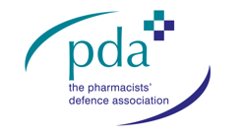

### 1. Student leaders ‘challenge the process’. Show how you have impacted on the pharmacy status quo to innovate, grow and improve your organisation.

### 2. How have you engaged your fellow students to follow and support your vision for the future of pharmacy in Wales?

### Enter text here:

### Enter text here:



## Wednesday 13th October, 2021

028 9099 9441

www.welshpharmacyawards.info

The Vale Resort, Glamorgan

### 3. Change can be stressful. How do you feel you can build confidence in your peers that even the greatest challenges can be met?

### Enter text here:

### 4. What do you consider are the key attributes in a leader and give two examples of how you have demonstrated your leadership values within the past year.

### Enter text here:

Please email entry form to: chris.flannagan@nimedical.info.

Or if you require any further information please contact Chris Flannagan:

Tel: 02890 999 441.

Entries MUST be accompanied by a digital photograph, at least 500KB for printing and multimedia quality.